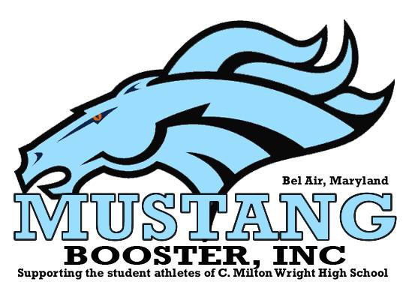

C. MILTON WRIGHT MUSTANGS BOOSTERS, INC.
2014-2015 SCHOLARSHIP APPLICATION

The C. Milton Wright Mustangs Boosters, Inc. is a Non-Profit Booster Club that supports all athletic programs at C. Milton Wright High School. Each school year Mustangs Boosters, Inc. offers a $1,000 first place and a $500.00 second place scholarship. The scholarships will be awarded to one male and one female Boosters member in each category to assist them in their college endeavors. The applicant must have been a member of Mustangs Boosters, Inc. each year they attended C. Milton Wright High School and the applicant must have attended at least one monthly Booster meeting, during their senior year, with their parent/guardian to be eligible for consideration for the scholarship. The award recipient will be announced at the annual Mustangs Boosters, Inc. Senior Athletic Awards Banquet on May 3rd, 2015 at the Richlin Ballroom.

All Mustangs Boosters, Inc. Scholarship Applications must be submitted by April 1, 2015. Applications received after April 1, 2015 will not be considered. Applicants can place their application in the Boosters Mailbox located in the C. Milton Wright High School Office or the application can be turned in to Ms. Wolfe in the Guidance Department. Applications will be reviewed and graded by a panel of no less than five professionals not associated with C. Milton Wright High School or Mustangs Boosters, Inc. Also, if the applicant fails to obtain a sponsor signature where required, the activity will not be scored accordingly. The Mustangs Boosters, Inc. will follow-up with Sponsors to verify that applicant was a participant in the listed activity, group or organization. Any false information, that is verified, will automatically disqualify the applicant from consideration. Awarded scholarships will be paid directly to the college of the Applicant’s choice.

APPLICANT GENERAL INFORMATION

NAME OF APPLICANT
ADDRESS OF APPLICANT
HOME PHONE NUMBER
CELL PHONE NUMBER
FATHERS NAME
MOTHERS NAME
FATHERS CONTACT NUMBER
MOTHERS CONTACT NUMBER
NAME OF SIBLINGS

POST HIGH SCHOOL

INTENDED COLLEGE

ACADEMIC
CURRENT CUMULATIVE GPA WHILE AT C. MILTON WRIGHT HS

SCHOLARSHIPS

As of April 1, 2015, have you been awarded any scholarships? | Yes/No
Have you been awarded a “Full-Ride” scholarship? | Yes/No

ATHLETIC INFORMATION

VARSITY SPORTS  PLAYED | YEAR  PLAYED | COACH | Coach Verification Signature

JV SPORTS  PLAYED | YEAR  PLAYED | COACH | Coach Verification Signature

RESUME

HIGH SCHOOL ACTIVITES (CLUBS, ORGANIZATIONS, ETC.):
List of High School Activity | Year | Teacher/Sponsor – Printed Name and Signature Required
COMMUNITY ACTIVITIES (CHURCH GROUPS, VOLUNTEER WORK, ETC.):
List of Community Activities | Year | Sponsor – Printed Name, Contact number, and Signature Required
LEADERSHIP ROLES (SGA Board, NHS Board, ETC.):
List of Leadership Roles | Year | Teacher/Sponsor – Printed Name and Signature Required
WORK EXPERIENCE OUTSIDE OF SCHOOL:
Name of Employer (Business) | Year | Supervisor’s Name, Contact Information

ESSAY REQUIREMENT
A TYPED PAPER (Maximum two-pages, must be double spaced) APPLICANTS ARE REQUIRED TO SUBMIT ON THE FOLLOWING TOPIC:

What impact has C. Milton Wright Athletics played in your life? Describe and explain which coach(s) has played an important role in your athletic career at C. Milton Wright. Explain how you became a better student and athlete because of your coach’s impact.

