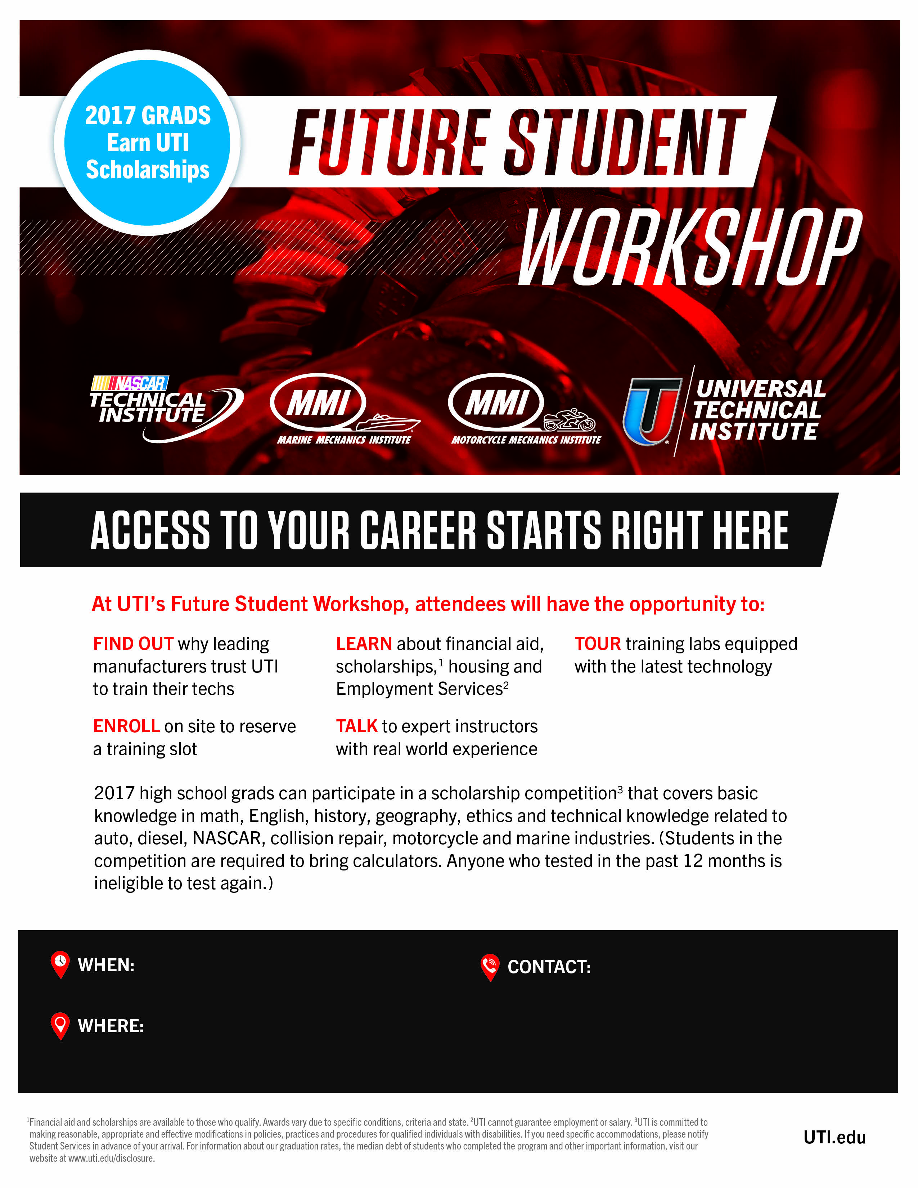

**Mike Ambrose**

(240) 405-4777

mikeambrose@uti.edu

750 Pennsylvania Dr.

Exton, PA 19341

Saturday April 1, 2017

Contact Mike Ambrose to schedule tour time